GUVI TASK 21

1. First create a ec2 ubuntu instance

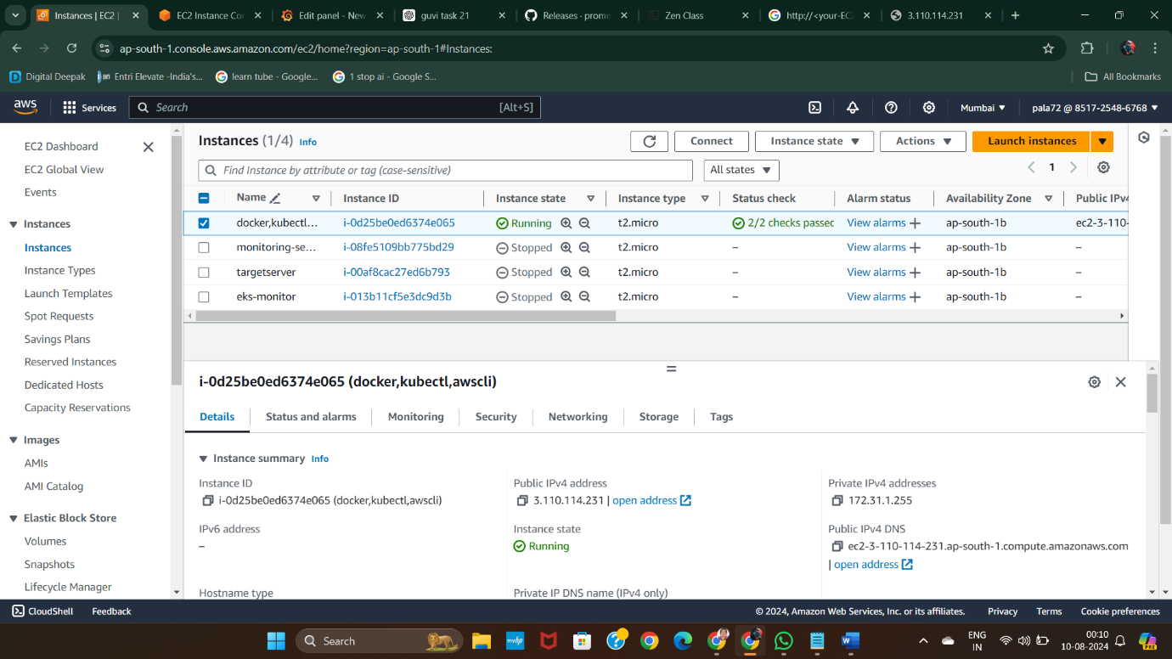

*1st instance is the instance I am going to use

2. Then open security group of that instance and open the ports below,

9090: Prometheus

3000: Grafana

22: SSH access

3. Then connect to your instance next it opens up in a new tab

4. give the update command to update the packages list

5. Next give the list of commands to install Prometheus and check for its staus at last whether is it running or not

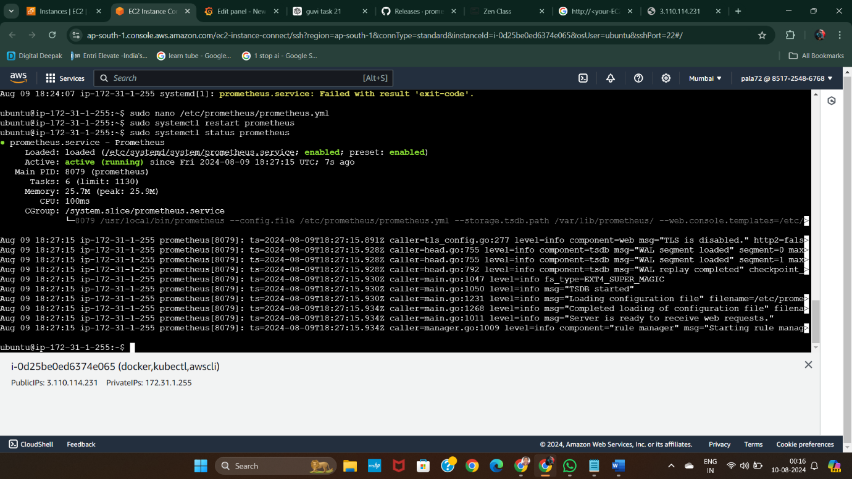

*Prometheus is running

6. Next give the series of commands to install Grafana

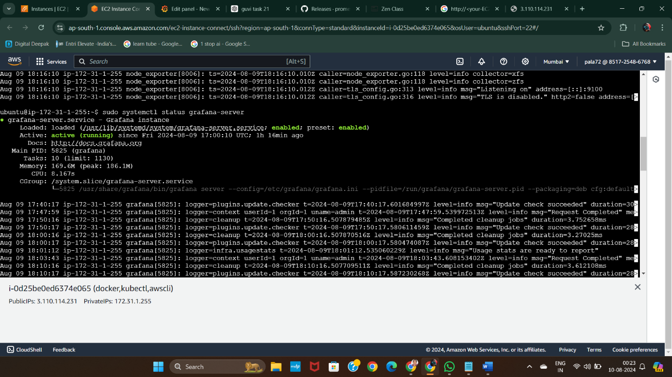

7. Install Node exporter so as to view CPU metrics usage [ for example ]

8. Download node exporter using the series of steps

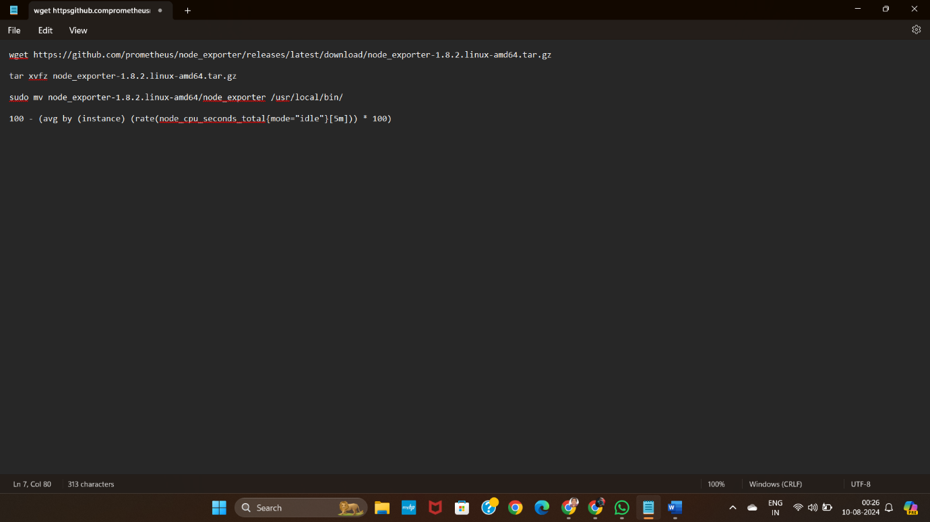

9. move binaries and create systemd service file

10. start and enable node exporter service

11. Configure Prometheus:

Edit prometheus.yml to include:

Scrape configuration for Prometheus itself.

Scrape configuration for Node Exporter.

12. Add Prometheus as Data Source in Grafana:

Access Grafana (usually on http://<your-EC2-public-IP>:3000).

Go to Configuration > Data Sources > Add data source.

Select Prometheus and enter the URL as http://<your-EC2-public-IP>:9090.

Click Save & Test.

13. Create a Dashboard in Grafana:

Create a new dashboard.

Add a new panel and enter the query for CPU usage:

100 - (avg by (instance) (rate(node_cpu_seconds_total{mode="idle"}[5m])) * 100)

Adjust the panel settings and save the dashboard.

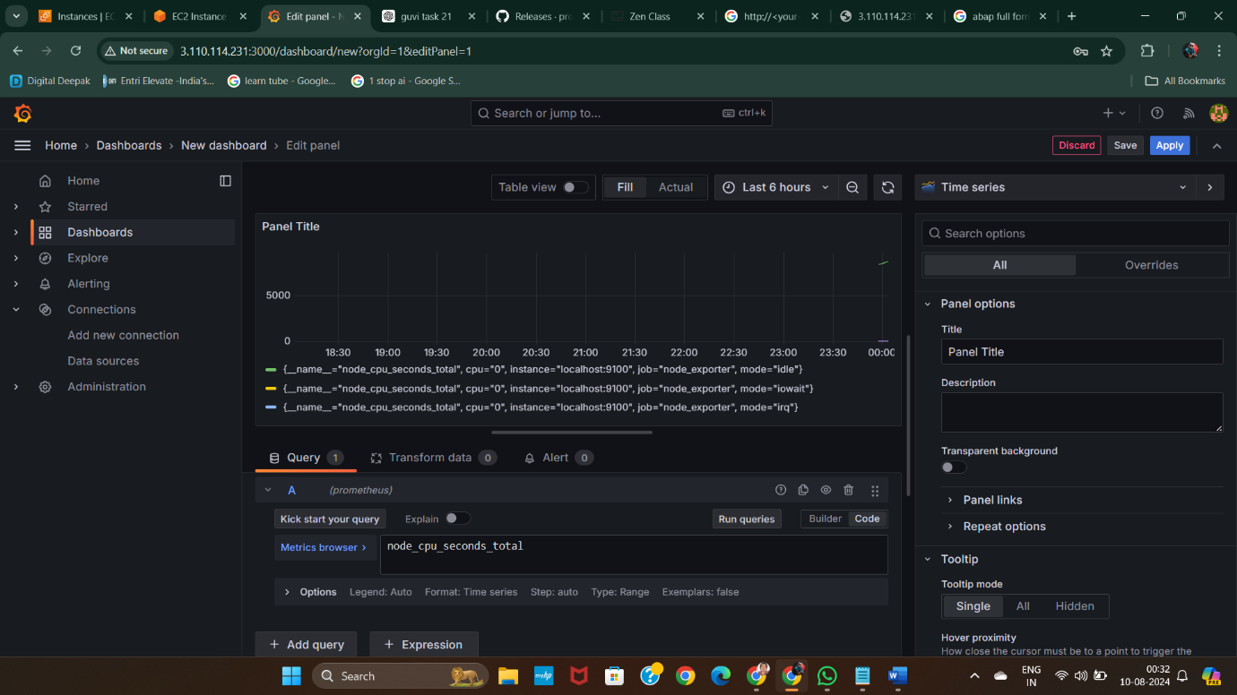

-----X-----